Submission of the

Public Service Alliance of Canada

and the

Union of Northern Workers

to the

Standing Committee on Social Programs

on

Bill 44: An Act to Amend the Hospital Insurance and Health and Social Services Administration Act

April 20, 2015

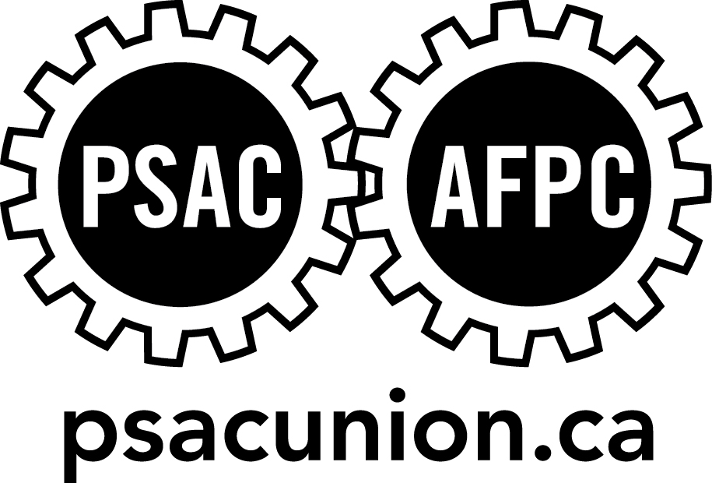
Mr. Chairman and Committee Members, I am Patty Ducharme, Director of Finance and Administration for the Union of Northern Workers. I am presenting to you today on behalf of Union of Northern Workers President Todd Parsons, who is unavailable and sends you his greetings. Joining me today is Marie Buchanan, the UNW’s Second Vice President.

The Union of Northern Workers is a component of the Public Service Alliance of Canada representing all the unionized employees of all the Health and Social Authorities affected by Bill 44, including the employees of the Stanton Territorial Health Authority and non-GNWT employees of the Hay River Health and Social Services Authority.

As the bargaining agent representing employees affected by Bill 44, the UNW is responsible for protecting, preserving and promoting the interests of our members. The UNW is vigilant in protecting the rights, benefits and entitlements obtained through collective bargaining.

The UNW does not object to the fundamental aims of Bill 44. However, we do object to the legislation's attempt to eliminate the collective bargaining gains of workers. We also object to the haste with which this Bill is being rushed towards passage.

In this submission, we will outline our concerns with Bill 44 and indicate the areas where we believe amendment of the Bill is necessary if this Bill is to emerge in a form that respects Canada's Charter of Rights and Freedoms.

It is our view that in its current form, this Bill is unconstitutional. It fails to respect jurisprudence of Supreme Court of Canada decisions which have enshrined the right of Canadian workers to collective bargaining.

The Committee must be aware that because Bill 44 fails to respect the constitutionally protected right to collective bargaining, the UNW will challenge any resulting law before the courts if flawed sections are not removed. .

Our major concern is with the effects of the legislation on current employees of the Hay River Health and Social Services Authority.

Sub-section 17(2) of Bill 44 would eliminate all contractual rights of employees and the union alike, under the collective agreement between the PSAC and the HRHSSA. That is the collective agreement currently in force.

Sub17.2 says:

(2) Subsections 15(1) to (5), as applied in respect of the former Hay River Health and Social Services Authority, do not apply in respect of any liability, including any contractual obligation, arising from employment related matters between the Hay River Health and Social Services Authority and its employees or the Public Service Alliance of Canada, except to the extent that Government expressly agrees, in a contract entered before this section comes into force, to assume such liability.

By this section, the Government refuses to assume any liability for the rights, benefits and entitlements of the workers prior to becoming members of the NWT public service.

The only mechanism provided in that provision for the preservation of the constitutionally protected collective bargaining process and its outcome—the collective agreement—is that of a contract entered into between the GNWT and the PSAC prior to the section coming into force. We have received no invitation to negotiate such a contract and yet the legislation continues to race through the legislative process. This is unacceptable and, again, we believe the approach is unconstitutional.

The UNW understands and supports that employees of the HRHSSA would become public service employees of the GNWT and entitled to the benefits of the collective agreement between the GNWT and the Union of Northern Workers.

However, the way this is being implemented endangers union members entitlements, be they pension or seniority related. It would also halt any grievances prior to the proposed transfer. These issues must be corrected.

Seniority based entitlements are a fundamental negotiated right for unionized employees. The longer one serves, the greater employees’ entitlement may be in matters such as wages, vacation time, shift selection or various other matters. Bill 44 does not protect those entitlements and this is unacceptable.

Pension entitlements are another area of concern. Bill 44 does not provide for the recognition of previous service with HRHSSA. It does not address the potential effects of transfer from the employer-provided plan in which employees currently participate, to participation in the pension scheme provided by the Public Service Superannuation Act. The retirement futures and income security of people who have devoted themselves to public service must be protected.

Bill 44 will not preserve and continue existing grievances that have been filed by employees. Bill 44 stops all grievance proceedings in their tracks and eliminates any possibility of employees obtaining redress and remedy for issues that may be extremely serious in nature. This is unacceptable.

Earlier this year, the Supreme Court of Canada released its decision in the case of Mounted Police Association of Ontario v. Canada (A.G.), 2015 SCC 1. In that decision, the Supreme Court ruled that the meaningful process of collective bargaining is now a constitutionally protected form of association under s.2(d) of Canada's Charter of Rights and Freedoms.

Bill 44 fails to respect that Supreme Court decision. By unilaterally destroying the collective bargaining entitlements of employees and union alike, without engaging in a meaningful process of collective bargaining, Bill 44 is unconstitutional and therefore, unlawful.

A better approach would have been to provide for the protection of the collectively bargained entitlements of workers through a clearly legislated succession of those entitlements. Any changes should have been sought through a meaningful process of collective bargaining.

It would have been better for the GNWT to present to the unions a contract proposal that would implement the required protection and preservation of worker entitlements.

Instead, we are faced with the prospect of seeing those entitlements destroyed unless we are able to secure negotiated contract protections prior to sub-section 17(2) coming into force.

The Minister of Human Resources and the Minister of Health and Social Services will a receive a letter on behalf of both UNW and PSAC. It will set out the essential components needed to solve the problems created for employees of the HRHSSA. We are asking the Committee to recommend major changes to the bill. If the bill is enacted without addressing these concerns, we will challenge the bill in court.

There are several other concerns with effects on employees of the GNWT.

Bill 44 will establish new powers of investigation, inspection, audit and quality assurance. The exercise of those new powers could have serious implications for individual employees.

Under Bill 44, investigations of "critical incidents", as well as inspections and audits, will all engage a duty of compulsory cooperation and participation that will extend to employees. Failure to comply with those duties may result in fines of up to $5000.00. Such investigations may have employment related consequences for employees, such as possible discipline or discharge in the event of findings of misconduct.

The UNW believes the legislation must be amended to provide for union representation and union assistance to employees during any investigations, inspections or audits.

Despite ministerial assurances, the UNW also has concerns with the potential for loss of positions through the amalgamation of the authorities. Although resourcing is not an element of the legislation, the Minister has raised this issue in introducing the legislation. Economies of scale in support positions such as purchasing, HR, administration, as well as diagnostic, medical travel, records management and other newly-created shared services may result in staff reductions. There must be no loss of positions or reductions in services vital to the well-being of patients. Good GNWT jobs, staffed up with few vacancies are essential to the economic health of many communities. The economic consequences of a poor transition could be very harmful to communities dependent upon good jobs for prosperity.

There are also concerns with redeployment and assignment of positions and duties. There is the potential for some workers to need retraining. There is also the potential for redeployment of some employees to different work locations, to meet the demands of new organizational models.

The state of the bill before us today reflects the fact that it was developed without meaningful consultation with the union that represent affected employees.

In its current form, the Bill violates the Charter of Rights and Freedoms S. 2(d) guarantee of freedom of association. It denies employees a process of meaningful collective bargaining and eliminates the negotiated entitlements of employees. It must be changed to eliminate these shortcomings.

As also stated, Bill 44 requires amendment to protect the union members right to representation and assistance in all instances of investigation.

Regarding implementation, there must no loss of positions, and sensitivity and flexibility in matters of retraining and redeployment.

A detailed written submission outlining these concerns will be provided to the Committee before the May 15 deadline.

I thank the Committee for its attention to these concerns and would welcome your questions.

